Listening for a Purpose: The White Lund Disaster

- Near which town was the National Filling Factory built?
M _ _ _ _ _ _ _ _

- Why was it built there? ()

- What percentage of men worked at the NPF (the National Projectile Factory)?
_ _ %
- What percentage of women worked at the NFF (the National Filling Factory)?
_ _ %
- Why were munition workers paid more than local mill workers?
- On which date did the fire break out?
____ __________________, 1917

- Why did the fire spread?
- When was the first explosion?
Monday at _ _ pm.

- When was the largest explosion?
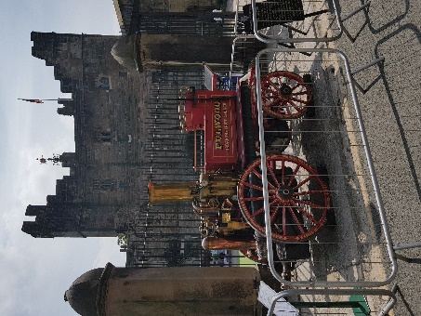
Tuesday at ___ am.

- How many fire brigades came to help?
_ _
This is one of the original fire engines!
- How many days did the fires burn?
From Monday to _____________, _____ days.

- Can you list three reasons why it was so difficult to fight the fires?
- 1
- 2
- 3
- How many men were killed?
_ _
- Can you list three possible causes of the fire?
- 1
- 2
- 3
- Bonus question 1 : what do you think townsfolk were doing when the first explosion went off?
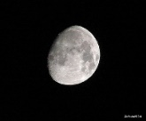
- Bonus question 2: Why do you think the newspapers didn’t report the disaster in any detail at the time?
Answers: 1. Morecambe; 2. Available housing & lodgings (unemployment and fewer holiday makers), road and rail links; 3. NPF: 53% male; 4. NFF 64 % female; 5. Because the work was dangerous 6. 1 October, 1917 (a Monday); 7. Buildings were made out of flammable materials (roofs out of wood) and explosive materials stored on site; 8. Around 10.30 pm on 1 Oct; 9. Tuesday 2 October at 3 am. 10. Thirteen, though more on the map? 11. Thursday, so three days. 12. (Also from timeline): At first too hazardous to do anything except take cover; shells exploding, burning debris flying; journey time for fire brigades (roads bad condition and blocked by those running away, engine trouble, horses shying); poor water supply; electric pump broken; Mayor of Lancaster turns off water supply; no standardised fire fighting equipment; the noise, the heat …; 13. Ten fatalities; 14. Air raid or attack from the sea (ship or submarine); sabotage (German? Irish?), spontaneous combustion or accidental, e.g. result of smoking.
15. Many were in bed or going to bed: one report subsequently commented on how many fled in their night clothes (in October? Without a coat?).
16. It might have allowed the enemy to work out where munitions factories were based and made them vulnerable to attack.

